<https://studybreaks.com/culture/fast-fashion/>



<https://www.nytimes.com/2019/12/17/style/fast-fashion-gen-z.html>







<https://www.youtube.com/watch?v=YOA0D0i5-fA>

<https://fortune.com/2016/11/16/neiman-marcus-rent-the-runway/>

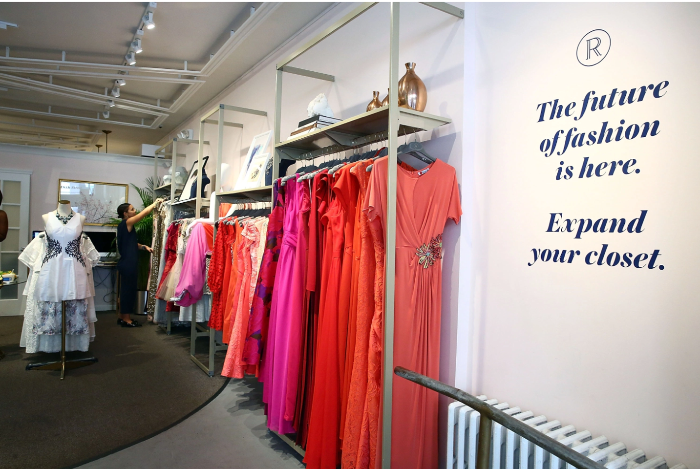

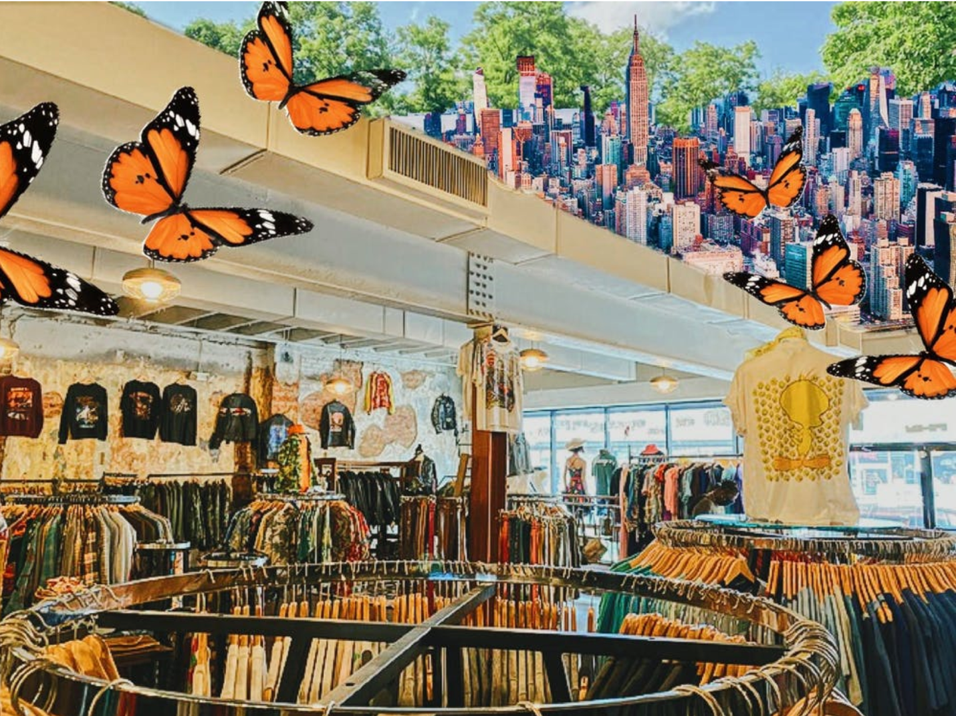

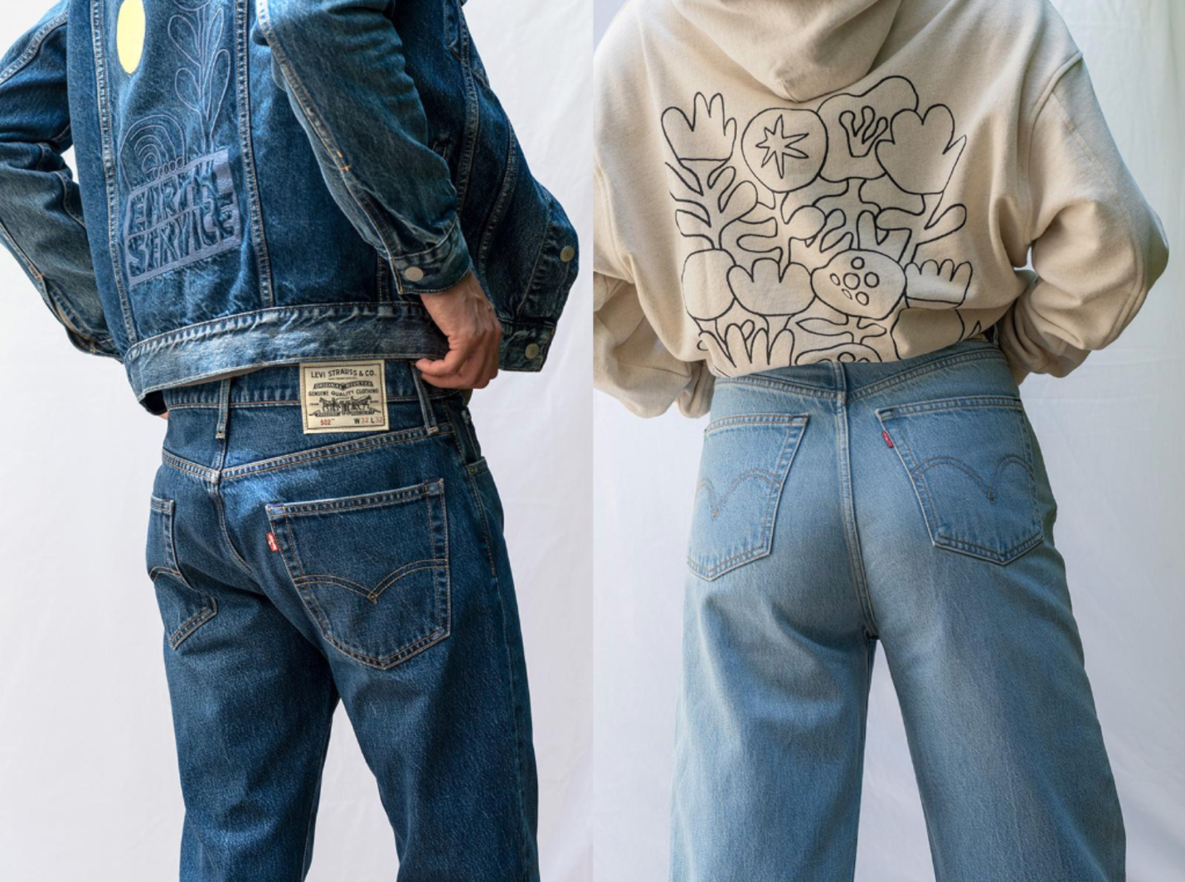

<https://www.greenqueen.com.hk/levis-launches-most-sustainable-jean-yet-made-with-circulose/>



<https://www.fodors.com/news/photos/these-versatile-travel-clothes-will-get-you-through-your-entire-vacation>